1. Copy the below files to some path.

* ilog_monitor.jar
* ilog_monitor.properties
* ilog (empty folder for log files)

1. ilog_monitor.properties has the server details & the time interval for monitoring. Whenever the properties file is modified, app should be restarted for the changes to get effect.
2. Open terminal & go to the path where the files are copied.
3. Execute the jar file using java 6 as below.

Suppose java 6 is available in path /usr/java6, then run the below command to start the monitoring app.

> **nohup /usr/java6/bin/java -jar ilog_monitor.jar &**

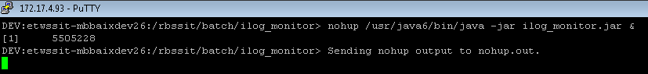

1. Monitoring App is started and displayed is the process id (here it is 5505228). Check the log file under log folder.
2. To stop the app use the kill command as follows. Use the process id displayed while starting.

> kill -9 5505228